Basic CRUD operations
man aluth module eka khadagaththa basic crud operation tika karanna. Ekata entity kiyal athawa package ekakuth damma relation class tika hadaganna.

Entity(class) ekak nam api bhawitha kranne relation ekak(table) hadaganna apita kiyanna puluwan. Relatoin = class kiyala. A adala relation class eken instanse ekak gaththtoth eka hariyta table ekak wage.

Apita mapping karanna puluwan akara dekak thiyanawa.
1. XML bawithaa karala karanna puluwan
2. Annotation bhawitha karala karanna puluwan

api xml gena wediya balanne nehe eka dan kal pena giya ekak nisa. Api kelinma annotation walata bahinawa.

- - - - - - - - - - - - - - - - - - - - - - - - - - - - - - - - - - - - - - - - - - - - - - - - - - - - - - - - - - - - - - - - - - - -
Api isselama entity ekak hadaganna Student kiyala eka encapsulated class ekakwenna one. Eka thama table ekakata map karanna yanne.

Database eke table ekak already thibbath kamak ne api ekata hari yanna entity class eka hadagnna one.

Ithin ape wede wenna encapsulated class eka heduwa pamanin sidda wenne nehe ekata api annotaion walin hari xml walin hari amathara thorathuru tikak denna one meka mehema wenna kiyala.

NOTE: api best practice ekak vidiyata Native Hibernate use kalath api Native Hibernate wala methods use karanne nehe. Api use karanne JPA wala methods godakma mokada industry eke unath hadissiye hari apita implementation ek awenas karanna one unoth Native hibernate walin gahala thibboth wena implemantaion ekakata migrate wenna amarui. Standard ekak vidyata api native hibernate wala dewal bhawitha karanne nehe industry ekedi. Mokada apita mapping ekath (ORM) sampuranayenma ain karanna wenawa native wala method use karala JPA walata maru wenna unoth. JPA wala methods use kaloth apita kisi gemak nethuwa OpenJPA, Eclipse wage ekakata pahasuwen maru wenna puluwan.

Palaweni annotation eka thama @Entity kiyana eka meken thama ape class eka table ekak kiyala handunaganne. Api kisima welawaka org.hibernate kiyana ewalin kawadawath import karnne nehe aip import karanne javax.persistance kiyana eken witharai.

Apita eka witharak karala madi mokada table ekakata primary key ekak thiyenna one eka nisa @Entity eka witarak thobboth apita compiler complain karanawa primary key ekath danna kiyala eka nisa api @Id annotation eka danawa.
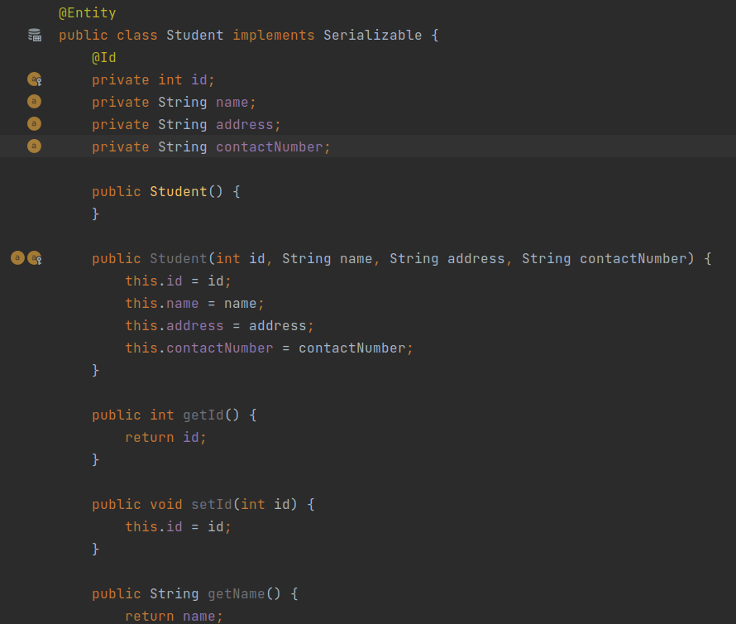

A witharak madi api Entity class eka heduwata api eka kiyanna one metaData build karanna kalin HibernateUtil eke. addAnnotatedClass(Student.class) kiyala. Meya entity ekak api meyawa map karala tiyenne kiyal. Ekathakota meya balnawa mekata gelapenna dtabase eka table ekak tiyanwada kiyala.
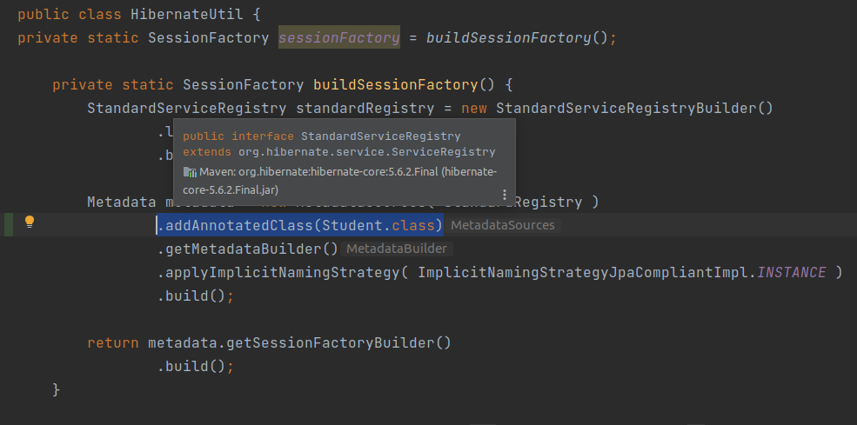
Eta passe wedagathma de thama api Session eka use karala monawa hari deyak karanawanam api Transaction use karanna one. Api issara transaction use kale monawa hari deyak table keeyakata effect wenna onenam witharane. Hebai hibernate walada JPA waladi mokak hari deyak karaddi transaction context ekak athule karanna kiyala eyala apita bala karanawa. Hema ekakma karana one eka nisa transaction context ekak athule.

READ operation hera anith dewal karnawanam transaction use karannama one. Read operatoin wlata transaction thibbath ekai neththath ekai nisa.

Eta passe api normal JDBC wala mokak hari insert ekak gahanawanam prepared statement ekak hari statement ekak hari aragena eken ape insert query eka wrap karala. Database ekata yawanna parameter set karala loku sellamak danawaneh. Meke a monawath karanna nehe kelinma object eka aragena ekata save wenna kiyanna witharai thiyenne.

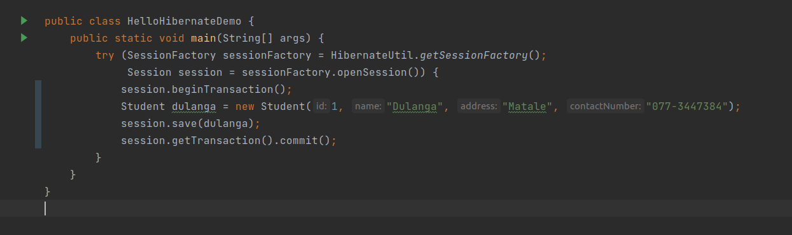

Meka mehema run karata hariyata weda karanne nehe mokada ape database eke meka save wenna table ekak hdala nethi nisa. Api ekata mehema wedak karanawa application.properties file ekata.
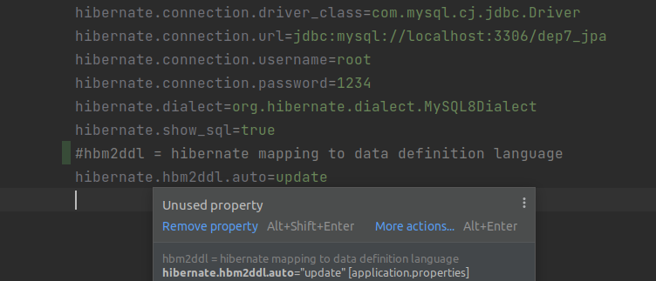
Api meke hbm2ddl.auto kiyana eka update karanawa ethakota mokada wenne ape database eka athule table ekak neththam table ekak hadala ekata save karanawa. Table ekak thiyanawanam a table ekatama save karanawa. Issella save une neththe man eka comment karala thibba nisa. Update witharak neme apita drop,create only, create-drop wage thawa keeyapayak mekata danna puluwan a a vidiyata eka perform karnawa. Doc eke automatic schema genaration yatathe me kathawathiyanawa. By default thiyenne none. Examples,

None – by default
drop – drop the table if exists. Aya aluthen hedenne nehe table eka left wenawa
create-only – table ekak hedila neththam eke table structure eka hedenwa. Already thibboth runtime error ekak enawa already meka hedila thiyenne kiyala.
Create- meke wenne table ekak thiyanawanam eka drop karala aya aluthen ekak hadananawa. Drop if exists and create table
create-drop – data base ekak thiyanawanam (table) mekila aya aluthen hedila session eka close wenakota aya mekila yanawa.
Validate – meka table ekath ekka map karala balanawa me kiyana kathawa(table) eka harida kiyala db ekath ekka.
Update – api godakma use karanne me update kiyana eka. Meka kisima welawaka drop weemak karanne nehe. Neththam aya hadanawa.

- - - - - - - - - - - - - - - - - - - - - - - - - - - - - - – - - - - - - - - - - - - - - - - - - - - - - - - - - - - - - - - -
dan apita pena vidiyata table eke names, column names okkoma thiyenne ape entity bean ekata anuwa. Class name ekata anuwa. Apita mewa apita ona vidiyata wenawas karaganna puluwan.
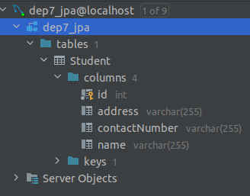
Apita eka mehema wenas karanna puluwan.

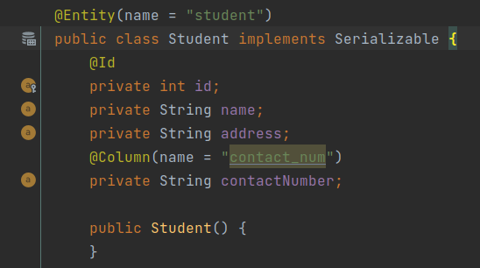

Apita colum eke varchar nethuwa wena mona hari use karanna onenam. Neththam varchar 255 madi nam. Apita eka chagne karanna puluwan @Column annotation eke column definition kiyana property eken.
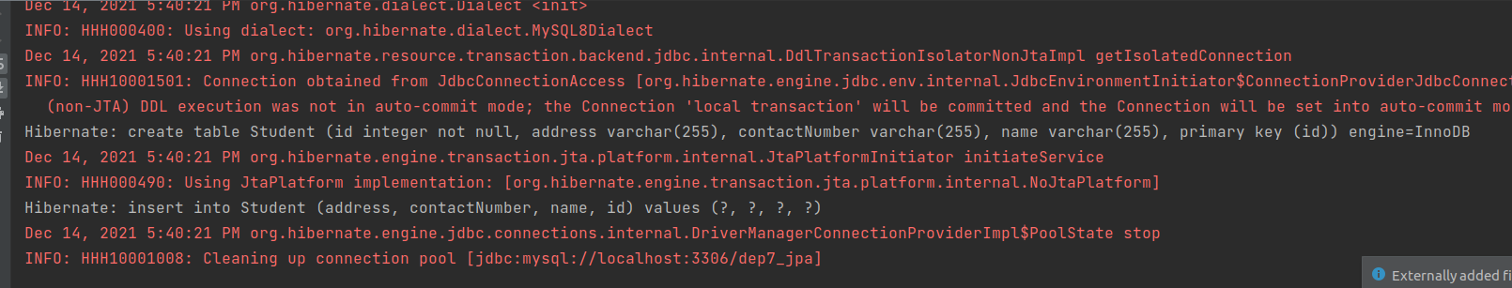
Database eka varchar(255) variable types walata default size thama set wenne but apita manually unath sizes set karann apuluwan kisi prashnayak nehe.

@Column(columnDefinition = “varchar(500)”)

mokak hari column ekakata null values pass karanna beri wenna hadaganna onenam.

@Column(nullable=”false”)

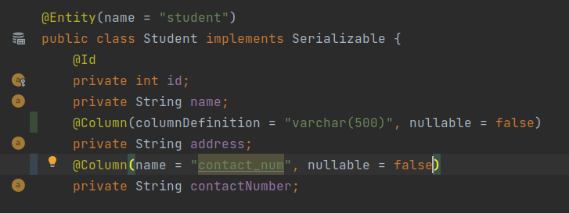

- - - - - - - - - - - - - - - - - - - - - - - - - - - - - - - - - - - - - - - - - - - - - - - - - - - - - - - - - - - - - - - - - - - - -
Difference persist() and save()

In JPA and Native Hibernate there are different methods to work with.

JPA wala api persist() kiyana eka use karanawa Natiave hibernate wala save() use karanawa. Me deke wenasak thiyanawa.

Persist() method eka void ekak save() eka return karanne Serializable interface ekak.

Serialazable eken return karnna adala object eke primary key eka. Ethakota apita Serializable kiyana swabhawayen apita return wenne adala object eke ID eka.

Save() method eka use kaloth apita aluthen add karapu kenage ID eka eka para return karaganna puluwan me return wena Serialazable eka nisa.

Mewata enne okkoma RuntimeExceptions SqlException enne nehe.

Read operation can be used without a transaction

try (SessionFactory sessionFactory = HibernateUtil.getSessionFactory();
Session session = sessionFactory.openSession()) {
Student student = session.get(Student.class, 1);
System.out.println(student);
}

We can get particular object using get method it should be passed relvent class and Serializable id(primary key)

Sessoin factory eke metaData eka hadala thiyenne builder design pattern eka use karala nisa apita addAnnotatedClass method eka use karala thawa ona tharam class add karaganna puluwan .

There is no update method in JPA and Native\

so we use object and its set method to update the method data.
try (SessionFactory sessionFactory = HibernateUtil.getSessionFactory();
Session session = sessionFactory.openSession()) {
session.beginTransaction();
Student sachintha = session.find(Student.class, 2);
System.out.println(sachintha);
sachintha.setContactNumber("0772622642");
session.getTransaction().commit();
System.out.println(sachintha);
}

above story is called dirty checking feature for updating in JPA and Native.

So let’s see how this dirty checking feature works

Update eka api control karanna yanne nehe eyalata thama control eka api denne.

meke thiyanawa paththarayak PersistanceContext kiyala hariyata nikan hariyta nikan servletContext eka wage.

Mekatama samahara aya kiyanwa first level cache eka kiyala.

A wagema PersistanceContext ekata apita kiyanna puluwan Session eka kiyalath meka harith nehe weradith nehe.

Ethakta me persistanceContext eka athule list of entities hari eka entity ekak hari thibboth eka ahuwenawa dirtyChecking feature ekata.

A kiyanne JPA hari Native hari boot karala thiyana eka anuwa a paththare athule thiyana eka diha balaagena innawa.

Api kiyanwa entity ekakata awastha keepayak thiyanawa kiyala.

1. New/Transient
A entity eka persistanceContext eken eliye thiyanakota api aluthenma hadapu ekaknam api ekata kiyanawa new/Transient state eke thiyenne kiyala.

Entity ekak aluthenma hadapu gaman thiyenen transient state eke ehemath neththam new state eke.

2. Manage State
A entity eka persistanceContext eka athule nam thiyenne api ekata kiyanawa ManageState eka kiyala. A wagema a thulata apu entity eka dirtyCheckingFeature ekata ahu wenawa.

Manage state eke thiyana awasthawe idan thawath awastha dekakata path kirime hekiyawath thiyanawa.

3. Detach statement
entity ekak already database eke innawanam api kiyanawa eya inne detach state eke kiyala. Wenath vidiyakin kiyanawanam eya aluth kenek newei nam eya kohe hari database eke thiyanawanam hebai manage state eke neththam ekata api kiyanawa eya inne detach state eke kiyala.

Manage satate ekata eliyenam eya aluth state eke neme nam inne/ eya aluthen hadapu entity ekak neme nam mokada eya alrady database eke inna kenek nama api eyata kiyanawa detach state eke kiyla.

Api hadagaththa entity ekata gelapenna record ekak database eke thiyanawanam detached kiyala kiyanawa state eka

DB eke thiyana record ekakin api entity ekak hadagaththoth eya inne detach state eke.
4. Remove State
thawa state ekak thiyanawa apita thanikarama manage state eken ain karala danna puluwan

NOTE:
api get hari find hari use karala database eken record ekak gaththoth eka wetenne manage state ekata. Ethkaota api manage state eke iddi a entity ekata change ekath kaloth eka eka parama database ekath ekka sync wenne nehe. Sync weemak sidda wenne api explicitly or transaction commit kaloth withrai. Ethakota kiyanawa manage state eke thiyana change eka database ekath ekka flush wenawa kiyala. Godak welawata api update ekak kaloth eka update karapu senin eka sidda wenne nehe mange state eke iddi persistance Context eka balagena innawa api karapu chagne eka diha. Balan idala commit ekak una gaman database ekath ekka sync karagannawa. Me wedeta aniwaren transaction awashyai.

NOTE:
ManageState eke thiyana ekak detached state ekata ganna apita evict() or detach() karanna puluwan manageState eke idala.

NOTE:
Context eka athule ape entity ekak thiyanawada kiyala balaganna puluwan session eke thiyanaw contains() kiyala method ekak meka athulata ape entity eka pass kalama true or false kiyala return karanawa.

NOTE:
new/transient state eke thiyana ekak mangeState ekata ganna krama godka thiyanawa ekata lesima kramaya thama save hari persist hari use karna eka.

Boho welawata api save ho persist karapu gamanma eya insert ekak gahaganen nehe eya first level cache eke thiyagannawa. A awashya dewal karala iwarala wela transaction eka commit karaddi or explicitly flush karana kiuwoth thama eya database ekath ekka sync karaganne.

Refresh()

* refresh ekedi wenne ayeth database eken select statement ekak wadina eka. Commit wenna kalin refresh kaloth ehema aya karapu change eka ain wela database eke thiyana vidiyata rcord eka gannawa.

Meken wenne newatha me state eka reload wenawa roll back karanawa wage.

JPA walatai Native walatai dekatama thiyenne refresh() method eka hebai weda karana vidiya poddak wenas.

ManageState eke hera(dirty checking) wena state ekaka thiyanawanam refresh karanna hekiyawa nehe.

// hibernate thinks this is in detache state but this really in new state
// mokada ekata hethuwa api me entity ekata ID ekak specify karapu eka
// mokdaa eya hema welema hithanne ah meyata primary key ekak specify karala thiyanawane eka nisa meya alaready DB eke inawa recod ekak kiyala
// api primary eka damme neththam eya hitha gannawa ehenam new state eke thama inna one kiyala

Hibernate waladi api refresh method eka use karana kota detached state eke thiyana ewath refresh karanna ida denawa.

